Atlas Omni-Scope I: Atomic Datum Closure and Cross-Scale Finite-Scene Grouping
Daniel Scieszinski / Atlas Solver Lab
2026-04-25
Date: 2026-04-25

STATUS
Status: Internal lab result paper Lane: Atlas Omni-Scope / Finite-Scene Grouping Evidence status: Ledgered scratch extraction with omni-radial crossing audit and full-field zero-set audit Canonical status: Not Phase I macro benchmark evidence Public status: Not approved for public release Primary result: Pb FCC first-shell atomic datum closure under declared Atlas readable branches Core claim: Atlas demonstrated lawful parity/grouping extraction on an atomic finite source scene using the same ledger-first architecture developed for macro weak-field scenes.

ABSTRACT
This paper reports the first Atlas Atomic Datum extraction: a finite-source atomic-scale scene consisting of one central lead datum and twelve surrounding equal-mass lead source nodes arranged as the first neighbor shell of an FCC local geometry. Using the scalar readable branch
Q_i(x) = M_i / r_i(x)^3,
with softening used only for numerical safety, two contribution-context residuals were evaluated:
Psi_max(x) = Q_0(x) - max_j Q_j(x),
which compares the central datum against its strongest individual surrounding competitor, and
Psi_sum(x) = Q_0(x) - sum_j Q_j(x),
which compares the central datum against the summed surrounding context. A ledger-first scratch extraction produced omni-radial zero-crossing records, residual diagnostics, and a full-field zero-set audit. The max-context branch recovered a discrete retained parity cell associated with FCC local grouping geometry, while the summed-context branch produced a tighter smooth grouped-context enclosure.
The result does not imply chemical relevance of atomic gravity, quantum gravity, a new force, a new field equation, or new atomic dynamics. It demonstrates something narrower but architecture-changing: Atlas can lawfully extract finite-scene grouping geometry from an atomic-scale declared source arrangement. This expands Atlas from a macro weak-field gravitational readability instrument into a cross-scale finite-scene grouping scope, with interpretation remaining strictly regime-dependent.

1. OPENING: THE EVENT
Atlas Solver began as a weak-field multi-source diagnostic instrument for gravitational readability in macro scenes. Its canonical work focused on declaring gravitational source rosters, defining readable contributions, comparing those contributions through residuals, extracting parity/GCS zero sets, filtering retained supports, and interpreting the result conservatively inside standard GR.
The Atomic Datum run changed the instrument’s apparent scope.
A finite atomic-scale source scene was declared using the same architecture: one central source datum and a surrounding first-shell source roster. The extraction was not merely a visual analogy. It generated a declared scene, node assignments, readable fields, residuals, omni-radial zero crossings, a Node -1 ledger, and a full-field zero-set audit.
The Atomic Datum run did not extend Atlas by metaphor. It extended Atlas by extraction.
The result was not a claim about atomic chemistry or quantum mechanics. It was a lawful bookkeeping result: the Atlas contribution-context grammar, originally developed for macro weak-field gravitational scenes, operated cleanly on a finite atomic-scale source arrangement when the scene, sources, readable branch, and context rules were declared.
That is the lab event recorded here.

2. CLAIMS AND NON-CLAIMS

2.1 Claims
This paper claims the following.
- A lawful finite atomic-scale source scene was declared.
- The Atlas scalar readable branch Q_i = M_i / r_i^3 was applied as weak-field diagnostic bookkeeping.
- Two residual/context rules were evaluated:
- Psi_max = Q_0 - max_j Q_j,
Psi_sum = Q_0 - sum_j Q_j.
- The max-context rule produced a closed discrete retained parity cell around the central datum.
- The summed-context rule produced a closed grouped-context enclosure around the central datum.
- The result was supported by omni-radial zero-crossing extraction and by a full-field zero-set audit.
- The event demonstrates cross-scale operational generality of the Atlas grouping method.

2.2 Non-claims
This paper does not claim:
- that atomic gravity is chemically significant;
- that Atlas explains atomic structure;
- that Atlas replaces quantum mechanics;
- that Atlas predicts molecular bonding;
- that Atlas has discovered quantum gravity;
- that the extracted structures are physical membranes;
- that the extracted structures are forces;
- that the extracted structures are observables by themselves;
- that this result is canonical Phase I macro evidence;
- that this result is ready for public release.
The result is dynamically modest but architecturally large.

3. FROM MACRO GCS TO FINITE-SCENE GROUPING
The original Atlas workflow can be stated compactly:
source roster
-> readable contribution
-> derived context
-> residual
-> zero set
-> retained support
-> closure diagnostics
-> ledger
-> conservative interpretation.
In macro gravitational scenes, the source roster may consist of planets, stars, or other weak-field masses. The readable contribution used in Phase I is typically the scalar tidal-readable branch
Q_i(x) = M_i / r_i(x)^3,
and pairwise parity is represented by
Psi_ij(x) = Q_i(x) - Q_j(x).
The Atomic Datum run used the same grammar, but the declared scene was finite and atomic-scale. The physical interpretation changed. The bookkeeping discipline did not.
Atlas does not require the same regime to carry the same interpretation. It requires the same declaration discipline to support lawful comparison.
This distinction is central. Atomic gravity is negligible for chemical dynamics, but a mass-energy datum remains a lawful contributor in GR bookkeeping. The question asked here is not whether atomic gravity governs chemistry. It is whether Atlas can lawfully extract contribution-context grouping geometry from a finite atomic source arrangement.
The answer from this scratch run is yes.

4. SCENE DECLARATION
Scene ID:
pb_fcc_first_shell_equal_mass_dimensionless
Run class:
Scratch / internal result run
Declared source scene:
One central Pb datum S_0.
Twelve surrounding Pb source nodes S_1 ... S_12.
Surrounding nodes arranged as the first neighbor shell of an FCC local geometry.
Coordinate convention:
Cartesian coordinates.
Central datum at origin.
Dimensionless nearest-neighbor distance D = 1.
Source positions:
S_0 = (0, 0, 0)
Surrounding sources are the twelve permutations of:
(+/-1/sqrt(2), +/-1/sqrt(2), 0),
with the zero coordinate cycling through x, y, and z.
Mass convention:
Equal Pb source masses.
In this equal-mass parity geometry, the common mass factor cancels from the shape extraction.
Approximation regime:
Static weak-field diagnostic branch.
Standard GR/SR bookkeeping only.
No claim of chemical authority.
Readable branch:
Q_i(x) = M_i / (||x - x_i||^2 + eps^2)^(3/2).
Analytic shorthand away from source locations:
Q_i(x) proportional to M_i / r_i(x)^3.
The scene is not an atom model in the chemical sense. It is a declared finite mass-datum arrangement used to test Atlas grouping extraction.

5. NODE DISCIPLINE
The Atomic Datum run was repaired into Atlas node discipline after an initial render-first process error. The lawful interpretation uses the following node assignments.

5.1 Node 0
Node 0 is the canonical global registration datum.
For this run:
Node 0 = central Pb datum S_0 at the origin.
This is a coordinate registration and launch anchor for the central extraction. It is not an ontological center of the lattice beyond the declared run.

5.2 Node 1
Node 1 is the lawful parent scene relation.
For this run:
Node 1 = explicit FCC first-shell parent/context candidate.
The surrounding twelve Pb source nodes form the declared context roster for the central datum. Node 1 is not a scalar floor and not a new source. It is the declared contextual relation used to ask a lawful grouping question.

5.3 Node 2+
Node 2+ are the physical source nodes in the declared diagnostic scene.
For this run:
Node 2+ = S_0 through S_12.
These are the only physical sources in the declared finite scene.

5.4 Node G
Node G is the geometric centroid of the declared source positions.
For the symmetric equal-mass first-shell scene, Node G coincides with the central datum within numerical precision.

5.5 Node B
Node B is the mass barycenter of the declared source roster.
For the equal-mass symmetric first-shell scene, Node B also coincides with the central datum within numerical precision.

5.6 Node -1
Node -1 is the certified relational ledger.
For this scratch run, Node -1 stores:
- source roster;
- source positions;
- readable field definition;
- residual rule;
- ray directions;
- crossing radii;
- crossing coordinates;
- strongest competitor for the max-context branch;
- residual checks;
- context-branch diagnostics;
- zero-set support records.

5.7 Node Psi
Node Psi is the extracted parity-comparison diagnostic layer.
For this run, Node Psi contains:
- max-context central retained parity cell;
- summed-context central grouped-context enclosure;
- zero-crossing support clouds;
- full-field zero-set audit outputs.
The extracted geometry belongs to Node Psi. It does not become a physical source and does not rewrite the source roster.

6. RESIDUAL RULES
Two context rules were used.

6.1 Max-context branch
The max-context residual is:
Psi_max(x) = Q_0(x) - max_{j>0} Q_j(x).
This asks when the central datum reaches parity with its strongest individual surrounding competitor.
Interpretation:
central contribution versus nearest/strongest individual rival.
For equal masses, the strongest individual competitor is the nearest surrounding source at a given location.

6.2 Summed-context branch
The summed-context residual is:
Psi_sum(x) = Q_0(x) - sum_{j>0} Q_j(x).
This asks when the central datum reaches parity with the grouped surrounding context.
Interpretation:
central contribution versus collective parent/context roster.

6.3 Why two branches matter
The same source roster supports multiple lawful grouping geometries because each residual asks a different declared contextual question.
The max-context branch is pairwise and competitive.
The summed-context branch is grouped and parent-like.
Pairwise competition produces a cell.
Grouped context produces an enclosure.

7. EXTRACTION METHOD
The corrected Atomic Datum run used a two-stage evidence structure.

7.1 Stage A: omni-radial zero-crossing extraction
Omni-radial rays were launched from Node 0.
For each ray direction u, the code searched radially along
x(r) = r u
and solved:
Psi_max(x(r)) = 0,
and
Psi_sum(x(r)) = 0.
Bisection was used to locate the first crossing.
The crossing points were stored in the Node -1 ledger.

7.2 Stage B: full-field zero-set audit
A 3D residual grid was then evaluated over a finite domain.
The scalar fields
Psi_max(x)
and
Psi_sum(x)
were sampled on the grid.
A zero-set reconstruction was performed as an audit and secondary visualization, not as primary evidence.

7.3 Render discipline
The initial process failure was that an analytic surface render was produced before the ledgered support was shown. That is not Atlas discipline.
The corrected discipline is:
crossing ledger first,
support cloud second,
residual diagnostics third,
surface reconstruction fourth and optional.
The surface is downstream of the crossing support, not the evidence itself.

8. RESULT I: MAX-CONTEXT ATOMIC DATUM CELL
The max-context branch produced a closed retained parity cell around the central datum.
The relevant residual is:
Psi_max(x) = Q_0(x) - max_j Q_j(x).
For equal masses, pairwise equality with a surrounding source j becomes:
Q_0 = Q_j,
which implies:
M / r_0^3 = M / r_j^3,
and therefore:
r_0 = r_j.
Thus each pairwise parity face is an equal-distance plane between the central source and one surrounding source.
The retained max-context cell is the intersection of the twelve nearest-competitor half-spaces. In the FCC first-shell geometry, that intersection is the central rhombic dodecahedral cell.
This explains the crisp facets and edges.
They are not a render artifact. They are the expected signature of equal-mass nearest-competitor parity.

8.1 Scratch diagnostics
From the omni-radial ledgered extraction:
Closed ray fraction: 1.000
Radius range: approximately 0.50008 D to 0.69204 D
Residual absolute maximum: approximately 1.78e-14
From the full-field zero-set audit:
Max-context zero-set vertices: 15,984
Max-context zero-set triangles: 31,964
Radius range: approximately 0.50013 D to 0.69789 D
The analytic expectation, ray-crossing extraction, and full-field zero-set audit agree on the central conclusion: the max-context branch produces a closed discrete retained parity cell.

9. RESULT II: SUMMED-CONTEXT ATOMIC DATUM ENCLOSURE
The summed-context branch produced a tighter, smoother enclosure around the central datum.
The relevant residual is:
Psi_sum(x) = Q_0(x) - sum_j Q_j(x).
Unlike the max-context branch, this comparison does not reduce to equality with one nearest competitor at a time. The surrounding sources act collectively under the declared readability rule.
The result is a grouped-context enclosure inside the max-context cell.

9.1 Scratch diagnostics
From the omni-radial ledgered extraction:
Closed ray fraction: 1.000
Radius range: approximately 0.40707 D to 0.41678 D
Residual absolute maximum: approximately 1.60e-14
From the full-field zero-set audit:
Summed-context zero-set vertices: 8,472
Summed-context zero-set triangles: 16,940
Radius range: approximately 0.40720 D to 0.41677 D
The summed-context surface is far less faceted than the max-context cell because the comparison is against a collective surrounding context rather than a single strongest individual competitor.

10. CENTRAL FINDING
The same finite atomic source roster produced two distinct lawful grouping geometries under two declared context rules.
Max context:
Q_0 = max_j Q_j
produced a discrete retained parity cell.
Summed context:
Q_0 = sum_j Q_j
produced a smooth grouped-context enclosure.
This is the central result of Atomic Datum.
Atlas was built to ask where gravitational contributions remain readable inside macro scenes. Atomic Datum shows that the same ledger-first grammar can ask where a lawful finite contribution remains readable inside a declared group.
The result does not broaden the physical claim. It broadens the instrument identity.
Atomic Datum shows that Atlas is not only a macro gravitational readability solver. It is a ledger-first finite-scene grouping instrument.

11. WHY THIS DOES NOT BECOME CHEMISTRY
The Atomic Datum run must not be misread.
Atomic gravity is dynamically negligible relative to electromagnetic and quantum effects. The gravitational contribution of a lead atom is lawful in GR bookkeeping but does not govern chemical bonding, electronic structure, orbital behavior, or molecular dynamics.
This paper does not claim that the extracted GCS/parity geometry has chemical authority.
The correct distinction is:
datum legitimacy is not dynamical authority.
A source can be lawful without being dominant.
A contribution can be real without being operationally important for a given physical question.
The Atomic Datum result matters because it proves an Atlas method capability, not because it replaces atomic physics.

12. WHY THIS STILL MATTERS
The result matters because finite arrangements are cataloguable.
Many macro gravitational scenes are difficult because the source roster, parent relation, observational domain, and environmental context are often incomplete. Atomic and molecular scenes are different. They can often be declared with extraordinary precision:
- element;
- isotope;
- atomic position;
- coordination number;
- crystal structure;
- molecular graph;
- bond length;
- bond angle;
- conformation;
- charge state;
- neighbor shell;
- lattice cell;
- solvent box or parent environment.
Atomic Datum suggests that Atlas can inspect such finite scenes as grouping systems once the relevant contribution channels are declared.
The first successful channel was gravitational mass bookkeeping. Future molecular inspection would not be limited to gravitational mass. It may require multiple readable channels, such as:
- mass;
- effective charge;
- covalent radius;
- van der Waals radius;
- partial charge;
- polarizability;
- electronegativity;
- electron-density proxies;
- bond-order descriptors;
- learned quantum descriptors.
The atomic result matters because it shows the grouping architecture can operate wherever a lawful finite contribution-context scene can be declared.

13. OMNI-SCOPE DEFINITION
This paper introduces the internal Atlas term omni-scope.
Definition:
An Atlas omni-scope is a ledger-first finite-scene inspection method that extracts relational grouping geometry from declared contribution-context systems across scale, while keeping interpretation regime-specific.
The term does not mean omniscience.
It does not mean universal physics.
It does not mean one field explains all systems.
It does not mean gravity explains chemistry.
It names the breadth of the inspection method, not the authority of any single physical channel.
The omni-scope is a method class:
declare scene,
declare datums,
declare contribution channel,
declare context rule,
ledger the relational state,
extract zero sets,
test closure,
interpret only inside the declared regime.

14. QUANTIZATION-ADJACENT, NOT QUANTUM
The Atomic Datum result sits near a dangerous conceptual edge.
A continuous field plus a declared grouping rule can produce discrete retained classifications:
- faces;
- cells;
- seams;
- vertices;
- junctions;
- component counts;
- closure states;
- parent/context assignments.
This is quantization-adjacent in the bookkeeping sense only.
It does not imply:
- quantized spacetime;
- quantum gravity;
- atomic spectra;
- energy quantization;
- physical discreteness of the underlying field;
- replacement of quantum mechanics.
The safe internal statement is:
Atlas can generate discrete relational classifications over continuous fields without claiming that the underlying field is discrete.
This is important because it gives Atlas a language for discrete grouping without physical overclaim.

15. PROCESS FAILURE AND LAB CORRECTION
The Atomic Datum event included a methodological failure.
An attractive analytic render of the max-context cell was produced before the Node -1 ledger and zero-crossing support were shown. Although the rendered object was mathematically legitimate, the workflow gave the render evidentiary weight before it had earned that status through Atlas discipline.
This is exactly the failure mode Atlas doctrine is designed to prevent.
The lab corrected the run by requiring:
- explicit scene declaration;
- node discipline;
- readable-field definition;
- residual definition;
- omni-radial crossing ledger;
- residual checks;
- full-field zero-set audit;
- render demotion to downstream communication.
The correction is part of the result, because the result became stronger only after the render was demoted.
Doctrine reinforced:
Truth first, render later.
Future default for Atlas sandbox extraction:
point clouds first,
crossing ledgers first,
support samples first,
surfaces only as optional secondary reconstruction.
Marching cubes, surface triangulation, and smoothed skins may be useful, but they do not certify a result.

16. EVIDENCE STATUS
This result is real enough to document and important enough to harden.
Current status:
Measured scratch extraction.
Ledgered.
Omni-radial zero-crossing supported.
Full-field zero-set audited.
Not yet sensitivity-hardened.
Not canonical.
Not public.
Evidence already present:
- declared source roster;
- declared Node 0;
- declared Node 1;
- physical Node 2+ source roster;
- readable scalar branch;
- max-context residual;
- summed-context residual;
- omni-radial crossing records;
- residual checks;
- full-field zero-set audit;
- machine-readable summary artifacts;
- diagnostic render outputs.
Evidence still required for promotion:
- independent rerun from clean code;
- ray-count sweep;
- grid-resolution sweep;
- tolerance sweep;
- domain sweep;
- softening sensitivity;
- point-cloud-first render bundle;
- comparison against other lattice scenes;
- stable file/output contract;
- lab-log and tracker entry if promoted into repo doctrine.

17. FUTURE WORK
Immediate work:
- Preserve this paper and the run artifacts.
- Repeat the Pb FCC first-shell run from a clean script.
- Produce point-cloud-first figures.
- Produce a compact machine-readable manifest.
- Add sensitivity sweeps.
Next benchmark scenes:
- BCC first-shell scene.
- HCP first-shell scene.
- Simple cubic first-shell scene.
- Diamond cubic scene.
- NaCl / rock salt scene.
- Unequal-mass toy lattice.
Later finite-scene molecular lane:
- Water.
- Methane.
- Benzene.
- Amino-acid residues.
- Protein pocket fragments.
- Multi-channel molecular readability.
Do not expand into molecular claims until the atomic finite-scene lane has its own benchmark ladder.

18. CONCLUSION
Atomic Datum did not change general relativity.
It did not make atomic gravity chemically relevant.
It did not discover quantum gravity.
It did change Atlas.
The Pb FCC first-shell run demonstrated that Atlas can lawfully extract finite-scene grouping geometry from an atomic-scale declared source arrangement using the same ledger-first contribution-context grammar developed for macro weak-field scenes.
The result reclassifies the instrument.
Atlas remains a weak-field gravitational diagnostics lab in its canonical Phase I lane. But the Atomic Datum result opens a second lane: Atlas as omni-scope, a cross-scale finite-scene grouping method in which contribution, context, residual, zero set, closure, and ledger form a general inspection grammar.
Final statement:
Atlas was built to ask where gravitational contributions remain readable inside macro scenes; Atomic Datum shows that the same ledger-first grammar can ask where any lawful finite contribution remains readable inside a declared group.

APPENDIX A: RUN ARTIFACTS
Primary scratch run directory:
/mnt/data/atlas_atomic_pb_fcc_lawful_run
Full-field zero-set audit directory:
/mnt/data/atlas_atomic_pb_fcc_zero_set_audit
Key artifacts from lawful mini-run:
scene_passport.json
summary.json
source_roster.csv
node_minus_1_omni_radial_ledger.csv
node_psi_retained_max_context_faces.csv
plots/atlas_lawful_atomic_gcs_audit_both_contexts.png
plots/node_minus_1_ledger_crossing_clouds.png
Key artifacts from full-field zero-set audit:
summary.json
node_psi_max_context_zeroset_vertices.csv
node_psi_max_context_zeroset_triangles.csv
node_psi_sum_context_zeroset_vertices.csv
node_psi_sum_context_zeroset_triangles.csv
max_context_mesh_residuals.csv
sum_context_mesh_residuals.csv
plots/fullfield_zeroset_audit_both_contexts.png
plots/fullfield_zeroset_max_context_only.png

APPENDIX B: RENDER POLICY
Atomic Datum reinforced the following Atlas render policy:
- Renders do not decide evidence.
- Point clouds are preferred for sandbox extraction review.
- Ledgered zero-crossing clouds should be shown before surface reconstructions.
- Marching cubes is a secondary visualization/audit tool, not a certification engine.
- Smooth surfaces may be used only after the support cloud and diagnostics are known.
- Any rendered surface must identify whether it is an analytic benchmark, ray-crossing interpolation, full-field zero-set reconstruction, or aesthetic communication layer.
Core rule:
Truth first, render later.

APPENDIX C: MINIMAL PSEUDOCODE
declare scene source roster S_i positions x_i masses M_i Node 0 Node 1 domain readable branch context rules
compute readable fields for each source i: Q_i(x) = M_i/(||x-x_i||^2 + eps²⁾(3/2)
compute residuals Psi_max(x) = Q_0(x) - max_j Q_j(x) Psi_sum(x) = Q_0(x) - sum_j Q_j(x)
omni-radial extraction generate ray directions u_k for each direction: solve Psi_max(r u_k) = 0 solve Psi_sum(r u_k) = 0 store crossings in Node -1 ledger
zero-set audit evaluate Psi fields on full 3D grid extract zero-set support as secondary audit compare to omni-radial crossing cloud
render show point clouds first show surfaces only after ledger support
interpret diagnostic only no force claim no chemistry claim no quantum claim no canonical promotion without sensitivity checks

END OF INTERNAL DRAFT v0.1

Figures
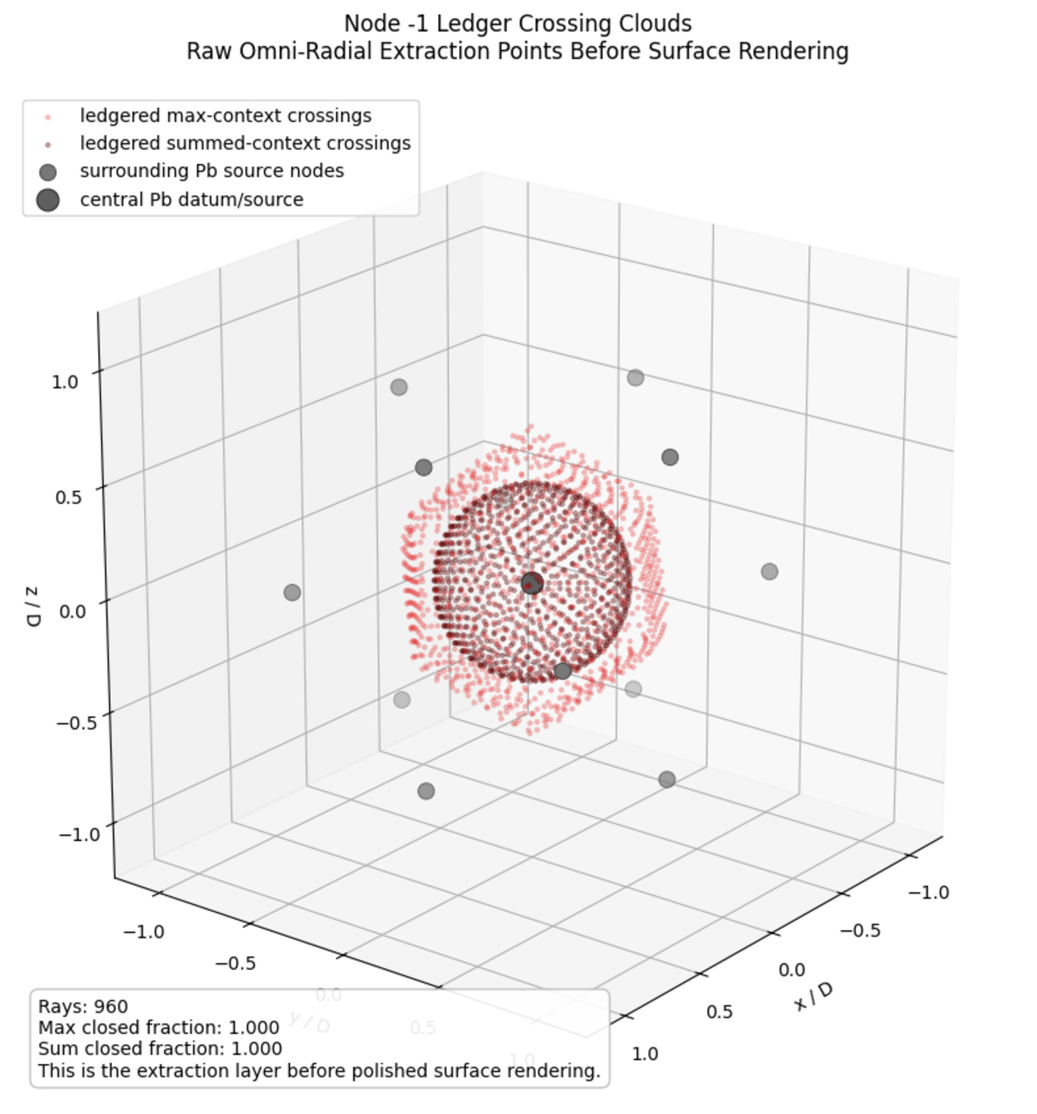
Figure 1. Node -1 ledger crossing clouds. Raw omni-radial extraction points before surface rendering. This is the primary evidentiary view for the Atomic Datum run.
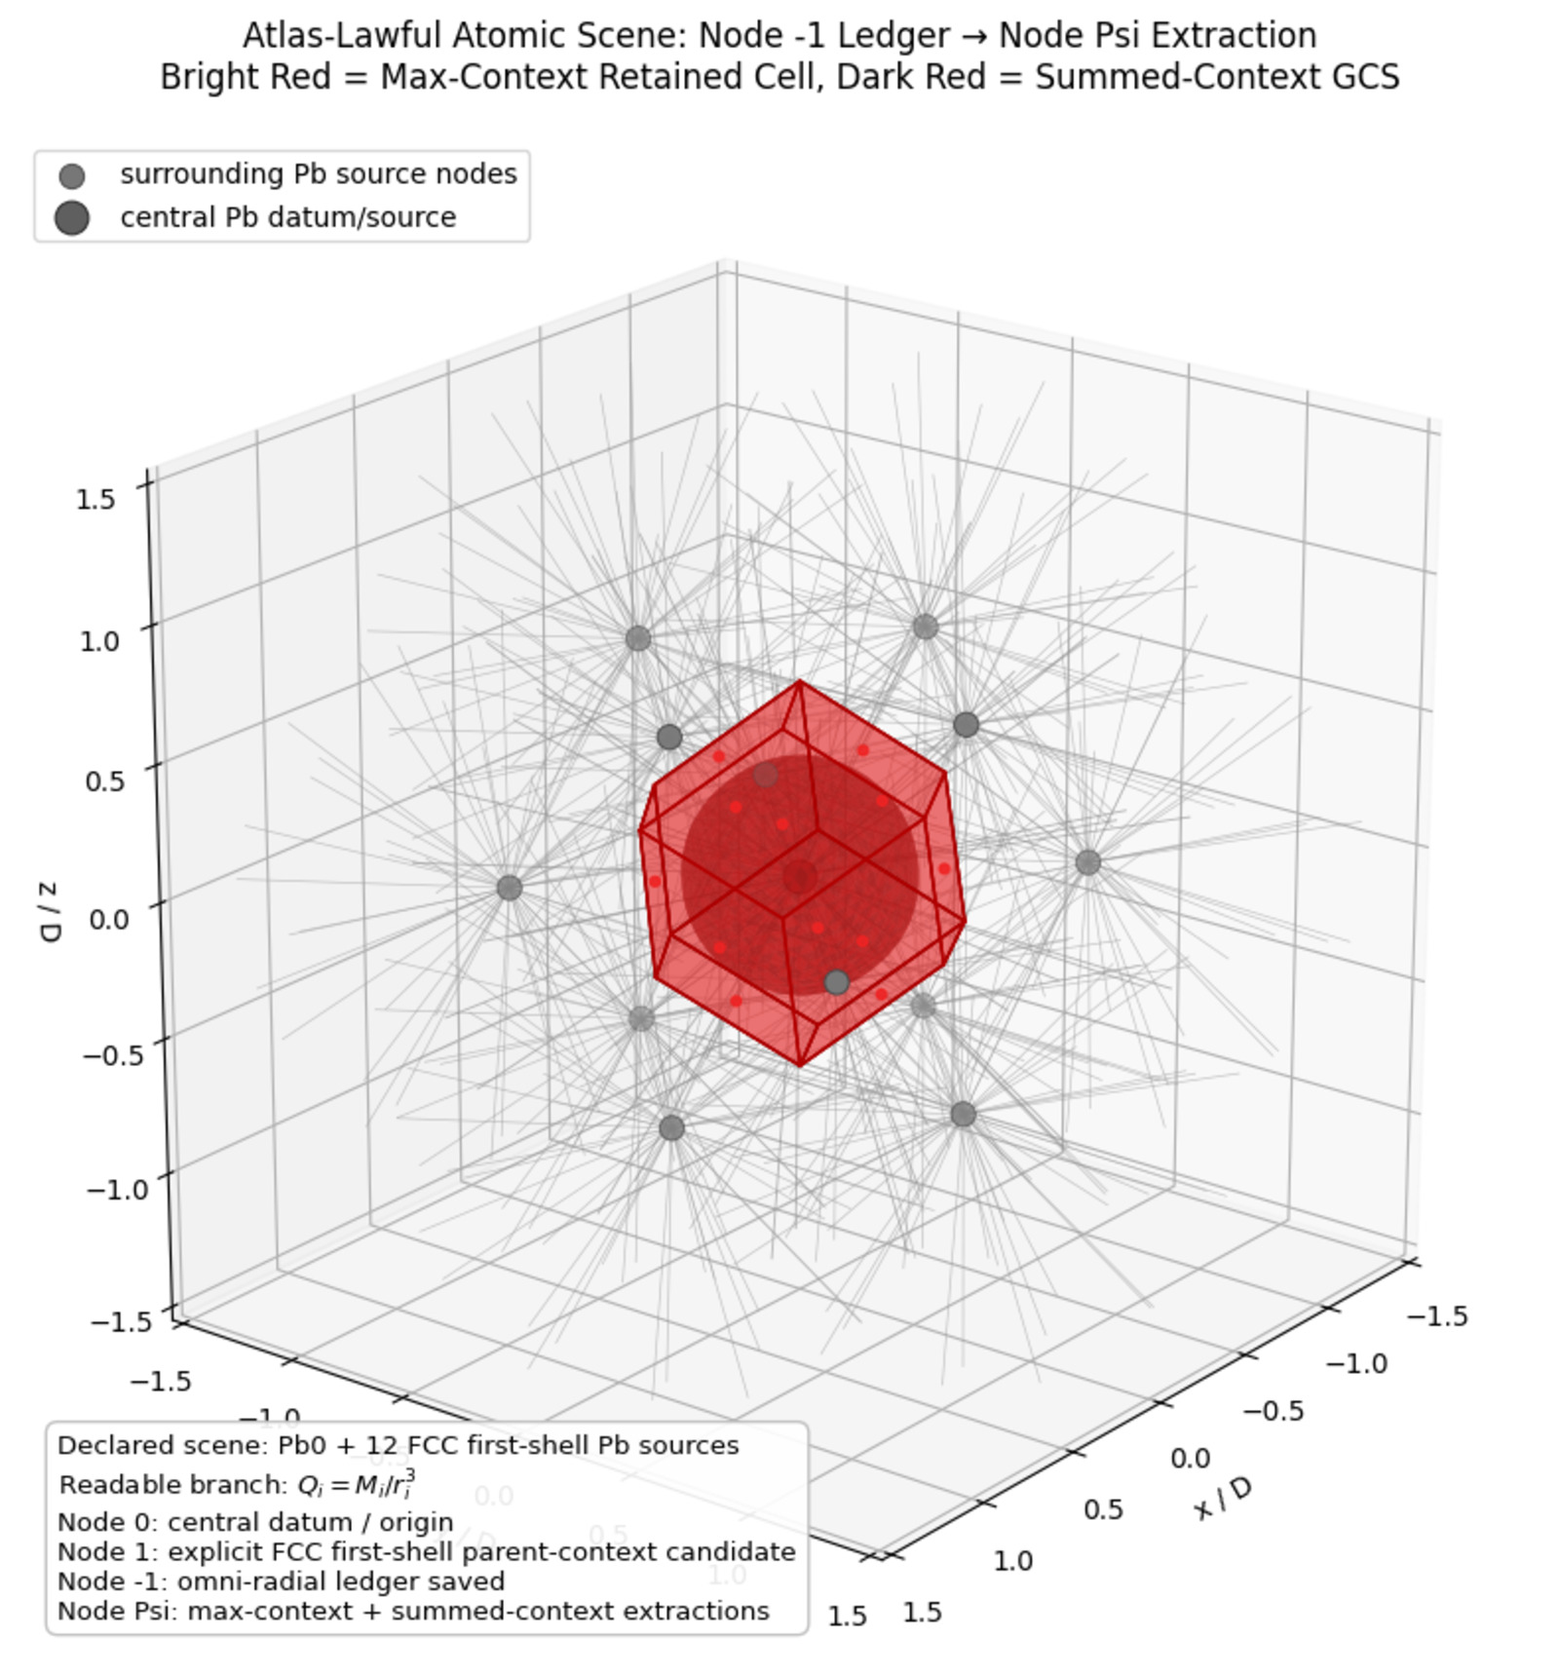
Figure 2. Atlas-lawful atomic scene: Node -1 ledger to Node Psi extraction. Bright red marks the max-context retained cell; dark red marks the summed-context GCS; grey rays show the construction/interrogation layer.

